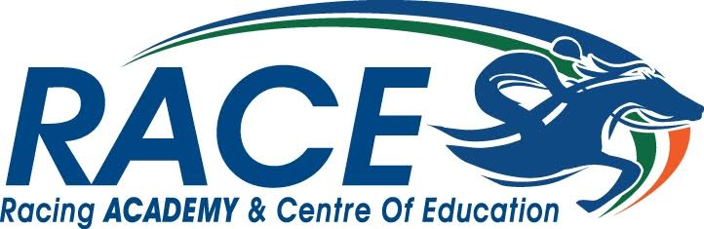

Parent/Guardian - Consent form and Child Protection Policy 2023
Suitability Testing for Trainee Jockey course

I am aware that _______________________ is going to undertake a five-day trial at RACE in June 2023.

I consent to their participation in this programme, and I am aware my child will be riding and around racehorses. I have supplied RACE with all relevant medical and personal safety information.

Relationship to the trainee
Full name (please print)
Contact mobile number (in case of emergency)
Allergies/Medical conditions we should be aware of
Signature
Date

Child Protection Policy
- The Board of Management and staff of RACE are committed to protecting the welfare of all children and young people in our care. We recognise our responsibility to take all reasonable steps to promote safe practice and to protect children and young persons from harm and abuse.
- All RACE staff have been Garda vetted and have completed child protection training.
- A full copy of our safeguarding statement is available on request.
- Any concerns regarding safeguarding issues or inappropriate behaviour should be communicated by trainees or parents to the Designated Liaison Person at RACE:

Caroline Strong (Operations Manager)
Main phone number: 045 522468

Submit to: office@racingacademy.ie

