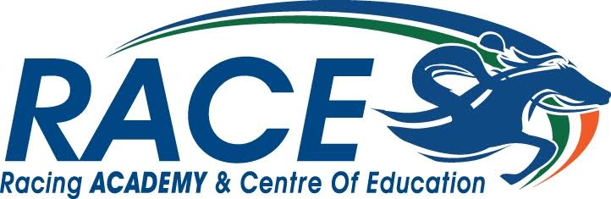

Parent/Guardian Contact Consent Form 2023

For those over 18 on the Trainee Jockey course suitability trial week

I _______________________ give permission to RACE to contact my parent/guardian as listed below while I am a resident at RACE for the trainee jockey suitability trial.

Parents/Guardians Name
Parent/Guardians Contact Number
Parent/Guardians Email Address
Signature
Date

Submit to: office @racingacademy.ie

